CSE 303 LAB:1 SECTION:3

Instructor:

MD. AL -IMRAN

Submitted by: Meftahul Zannat

Student ID:

2018-2-60-049

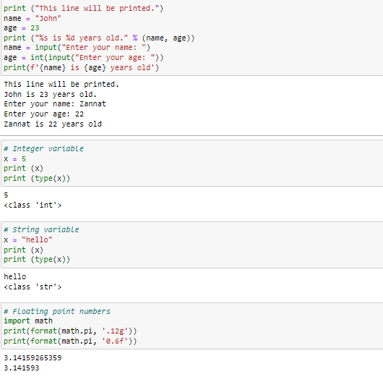

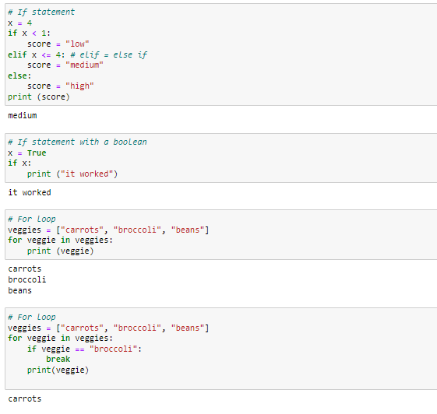

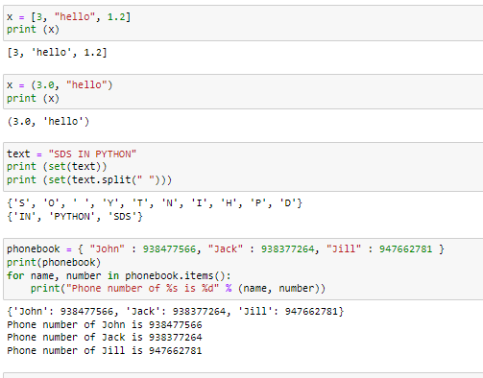

1. Given two integer numbers, write a Python program to return their product. If the product is greater

than 1000, then return their sum. Read inputs from the user.

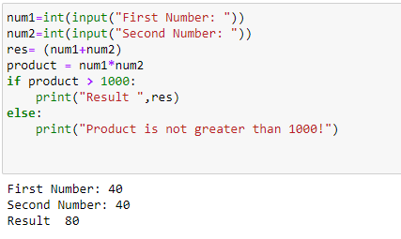

2. Write a Python program to find the area and perimeter of a circle. Read inputs from the user.

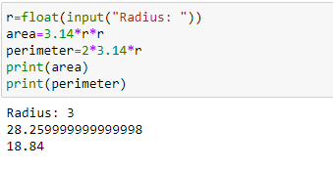

3. Write a Python program to calculate the compound interest based on the given formula. Read inputs

from the user.

A = P * (1 + R/100)

T where P is the principle amount, R is the interest rate and T is time (in years).

Define a function named as compound_interest_<your-student-id> in your program.

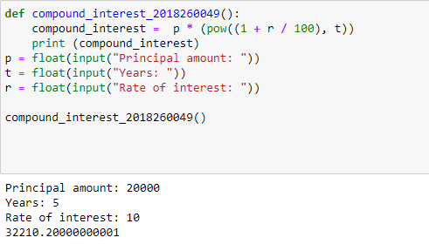

4. Given a positive integer N (read from the user), write a Python program to calculate the value of the

following series.

1^2 + 2^2 + 3^2 + 4^2 .... + N^2

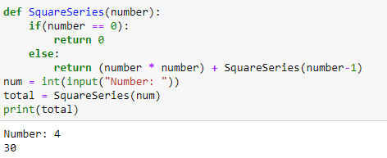

5. Given a positive integer N (read from the user), write a Python program to check if the number is

prime or not. Define a function named as prime_find_<your-student-id> in your program.

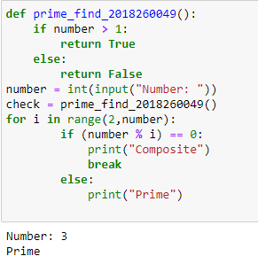

6. Given a positive integer n (read from the user), write a Python program to find the n-th Fibonacci

number based on the following assumptions.

Fn = Fn-1 + Fn-2 where F0 = 0 and F1 = 1

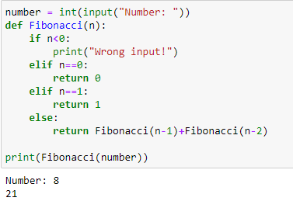

7. Given a list of numbers (hardcoded in the program), write a Python program to calculate the sum of

the list. Do not use any built-in function.

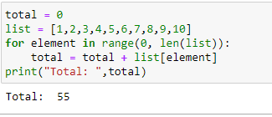

8. Given a list of numbers (hardcoded in the program), write a Python program to calculate the sum of

the even-indexed elements in the list.

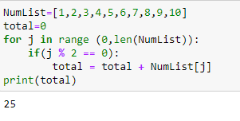

9. Given a list of numbers (hardcoded in the program), write a Python program to find the largest and

smallest element of the list. Define two functions largest_number_<your-student-id> and

smallest_number_<your-student-id> in your program. Do not use any built-in function.

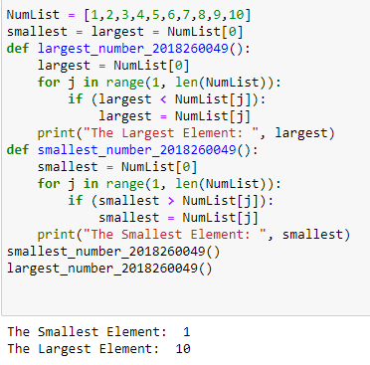

10. Given a list of numbers (hardcoded in the program), write a Python program to find the second

largest element of the list.

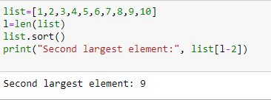

11. Given a string, display only those characters which are present at an even index number. Read inputs

from the user.

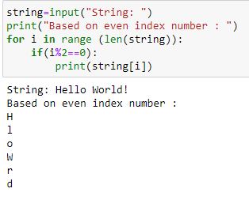

12. Given a string and an integer number n, remove characters from a string starting from zero up to n

and return a new string. N must be less than the length of the string. Read inputs from the user. Do

not use any built-in function.

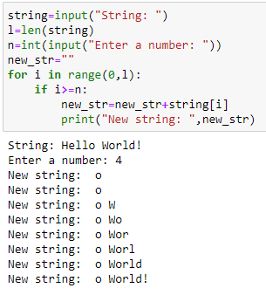

13. Given a string, find the count of the substring “CSE303” appeared in the given string. Do not use any

built-in function.

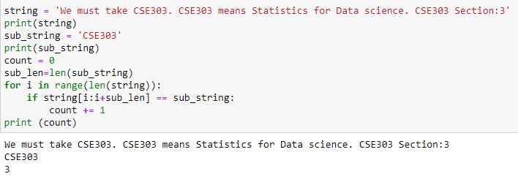

14. Given a string, write a python program to check if it is palindrome or not. Define a function named

palindrome_checker_<your-student-id> in your program.

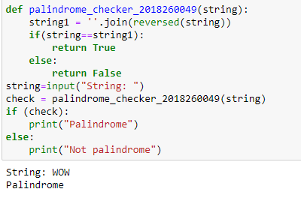

15. Given a two list of numbers (hardcoded in the program), create a new list such that new list should

contain only odd numbers from the first list and even numbers from the second list.

